Linux Fundamentals Lab Exercise

Name: Charumadhi M
Reg no: 3122245002012

Task 1: Directory and File Operations

Question: Create a directory named linux_lab, navigate into it, create the files students.txt, script.sh and output.txt, then display the current working directory and list all files.
Command(s) used: mkdir linux_lab → cd linux_lab → touch students.txt script.sh output.txt → pwd → ls -l

Screenshot:
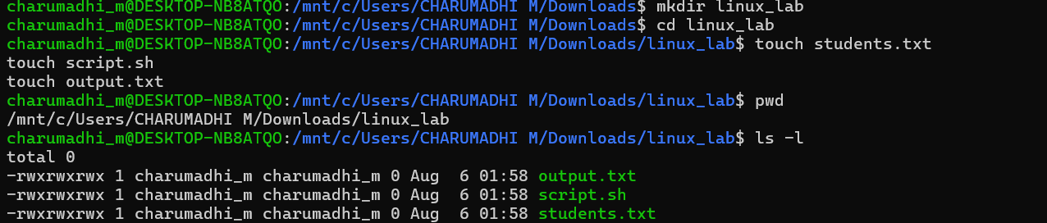
Result: The directory linux_lab was created and entered. All three required files (students.txt, script.sh, output.txt) were created successfully, as confirmed by the pwd and ls -l output above.
Task 2: Create and Edit a File
Question: Using a Linux text editor (nano or vim), add the given student records to students.txt, save it, and verify its contents.
Command(s) used: nano students.txt (edit & save) → cat students.txt
Screenshot:
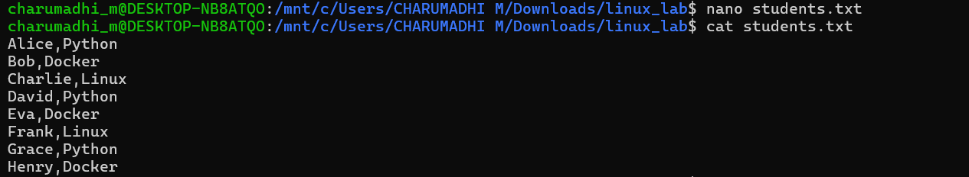
Result: students.txt was edited in nano and saved with all 8 student records. The cat command confirms the file contents match the required data exactly.

Task 3: Text Processing
Question: Display all records containing "Python", "Docker", and "Linux" respectively, using grep.
Command(s) used: grep "Python" students.txt | grep "Docker" students.txt | grep "Linux" students.txt
Screenshot:
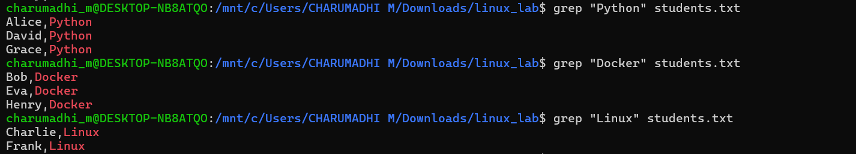
Result: grep successfully filtered and displayed 3 Python records, 3 Docker records, and 2 Linux records from students.txt.
Question: Count the number of records containing "Python", save that count into output.txt, and display the contents of output.txt.
Command(s) used: grep -c "Python" students.txt → grep -c "Python" students.txt > output.txt → cat output.txt
Screenshot:
Result: The count of Python records is 3. This value was redirected into output.txt using the > operator, and cat output.txt confirms it was saved correctly.
Task 4: Shell Scripting
Question: Create a shell script script.sh that displays a welcome message, the current user, the current working directory, and the current date & time. Run the script from the terminal.
Command(s) used: nano script.sh (write script) → cat script.sh → chmod +x script.sh → ./script.sh

Screenshot:
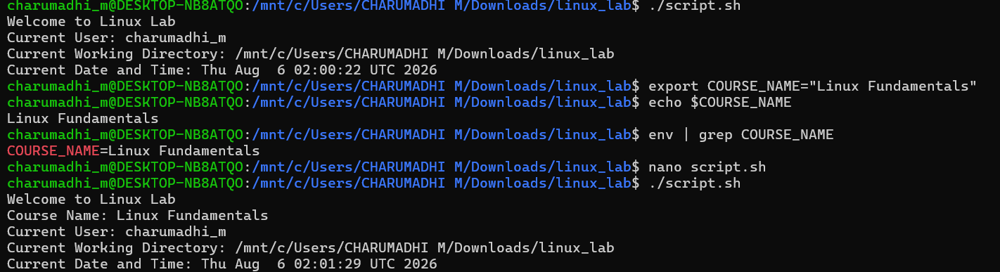
Result: script.sh was created with the required echo statements using $(whoami), $(pwd) and $(date), made executable with chmod +x, and executed successfully — printing the welcome message, current user, working directory, and system date/time.

Task 5: Environment Variables
Question: Create an environment variable COURSE_NAME with the value "Linux Fundamentals", display its value, verify it is exported, and then modify script.sh to also display COURSE_NAME along with the other system information.
Command(s) used: export COURSE_NAME="Linux Fundamentals" → echo $COURSE_NAME → env | grep COURSE_NAME → nano script.sh (edit) → cat script.sh → ./script.sh
Result / Screenshot:
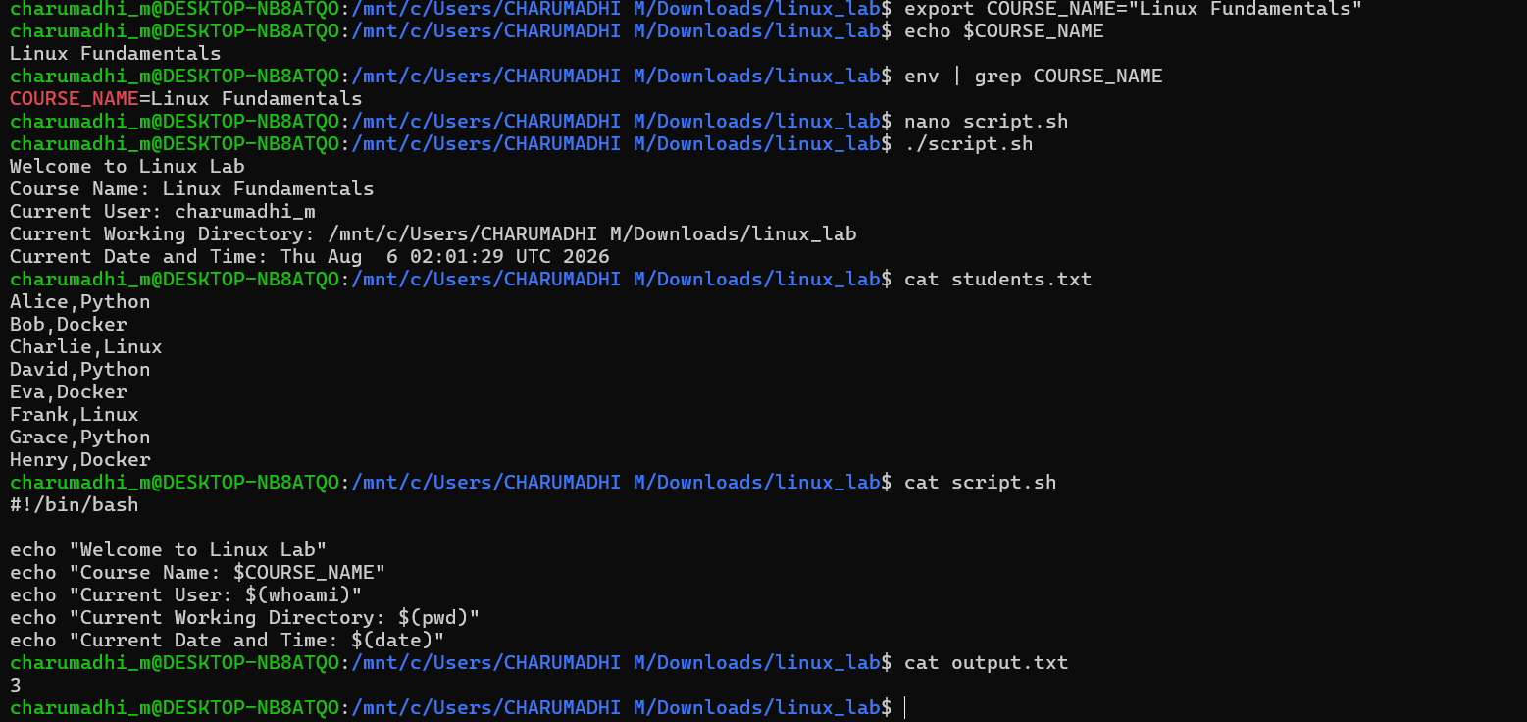
Result: The COURSE_NAME environment variable was created and exported successfully — confirmed via echo and env | grep COURSE_NAME. script.sh was updated to include an extra echo line for $COURSE_NAME, and running the updated script confirms it now prints the course name alongside the user, directory, and date/time.

File Contents

students.txt
Alice,Python
Bob,Docker
Charlie,Linux
David,Python
Eva,Docker
Frank,Linux
Grace,Python
Henry,Docker

script.sh
#!/bin/bash
echo "Welcome to Linux Lab"
echo "Course Name: $COURSE_NAME"
echo "Current User: $(whoami)"
echo "Current Working Directory: $(pwd)"
echo "Current Date and Time: $(date)"

output.txt
3

